DarkSpace Server Backend Design Document
10/03/2003

This document covers the overall design of the new server backend for DarkSpace. This document serves two main purposes, one to fully document the design and assist in keeping the design in check.

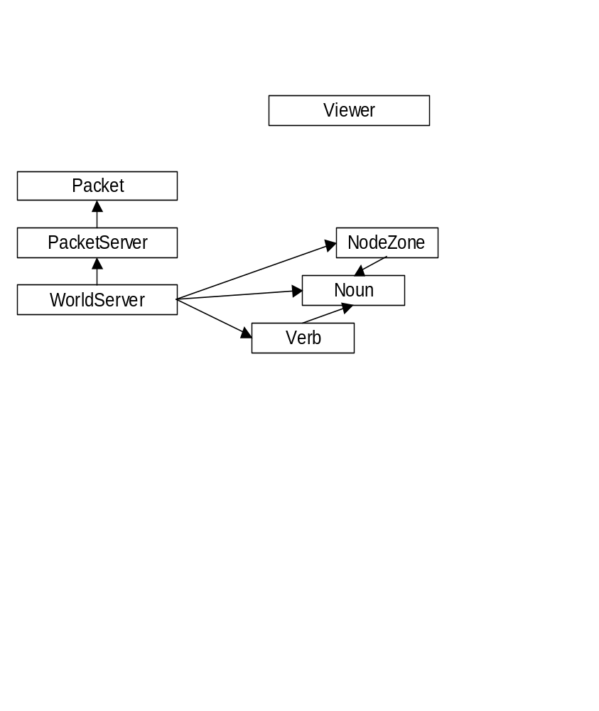

C++ Classes

NodeZone

Noun

Verb

UniverseServer

UniverseContext

Packet
This base class is used to contain data to be exchanged between servers and clients or other servers. The packet class is derived from the FileMemory class in Medusa, making it capable of being used by InStream and the OutStream classes.

A packet has the following properties:

Priority
This 1 byte value specifies the importance of the packet information. The priority level is only used if a connection is already saturated, in that case a packet may be placed in a queue based on its priority level to be sent at a later time.

Type
This 1 byte value specifies the type of packet. Different packet types will be handled by packet destination object.

Origin
This UniqueNumber is the ID of the sender of this packet. It is used to validate the packet when it’s received remotely.

Destination
An array of WidgetKey’s that specify the destination of this packet. Use by the UniverseServer for routing purposes.

